Members:

Bumacod, E-Jhay V.

Montemayor Myline C

Cuenza Louisa Anne O

Sevillena Jan Alden

Bacayo Gerrence Brylle

**Library Management System**

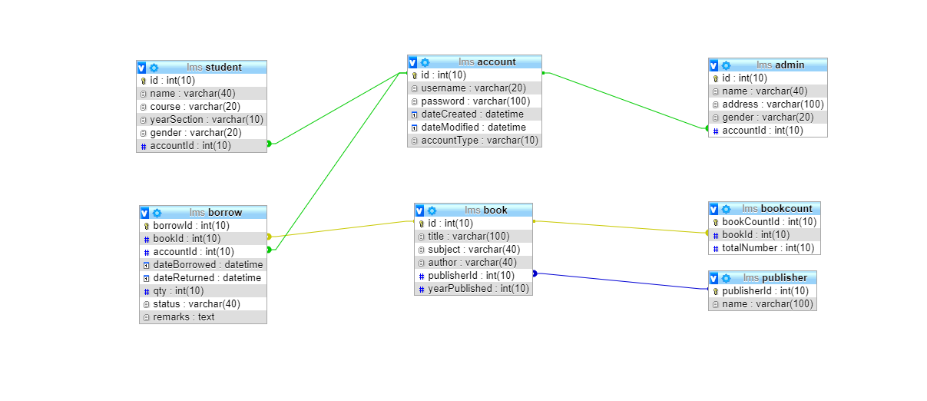**Entity Relationship Diagram**

In the database there are “admin” and “student” table. Both of them has a foreign key that references the “account table”. In the “book table” there was a foreign key that references the “publisher table” while in the “borrow” and “bookcount” table. They both have a foreign key that references the book table to get all of its property.

**Screenshots and Function of every pages**

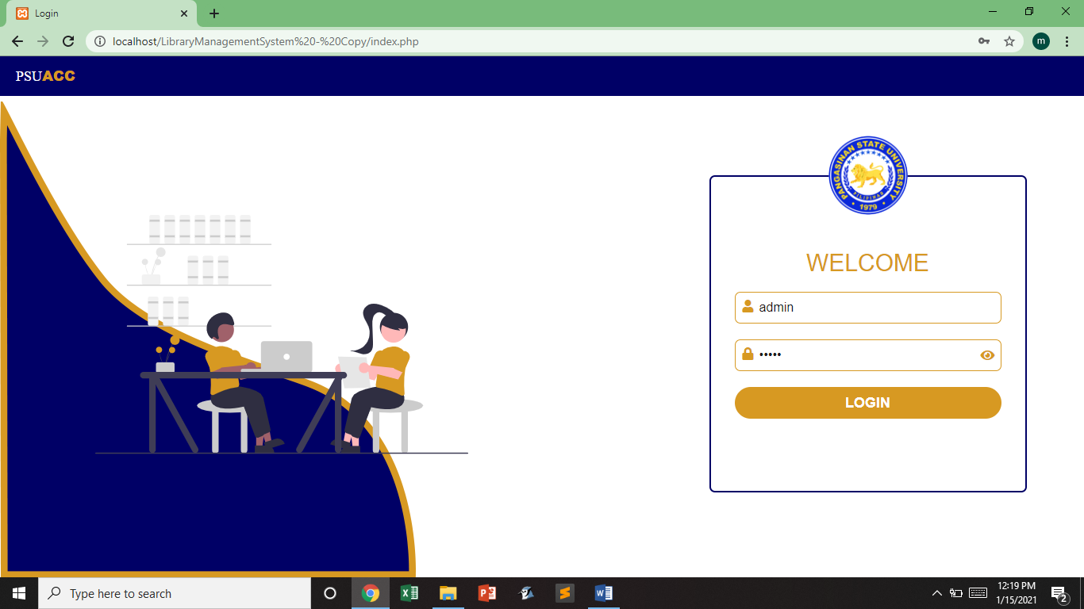

**Login Page:** Admin and Student can log in their account in this page but they have different destination when they logged in.

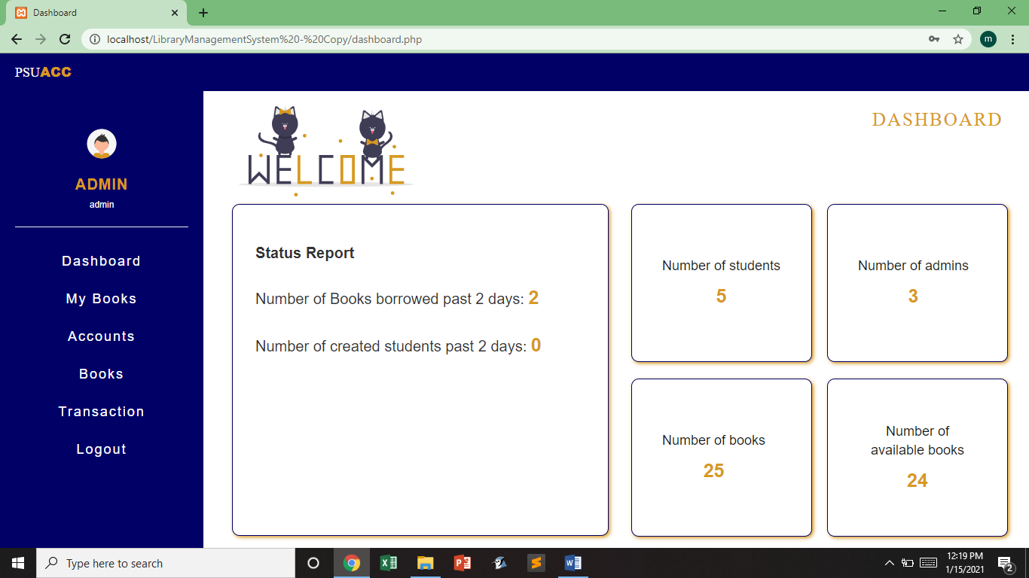

**Admin DashBoard:** In this page, all information about the Library is visible to the admin. Just like the Number of Admins, Students, Books and Availabale books.

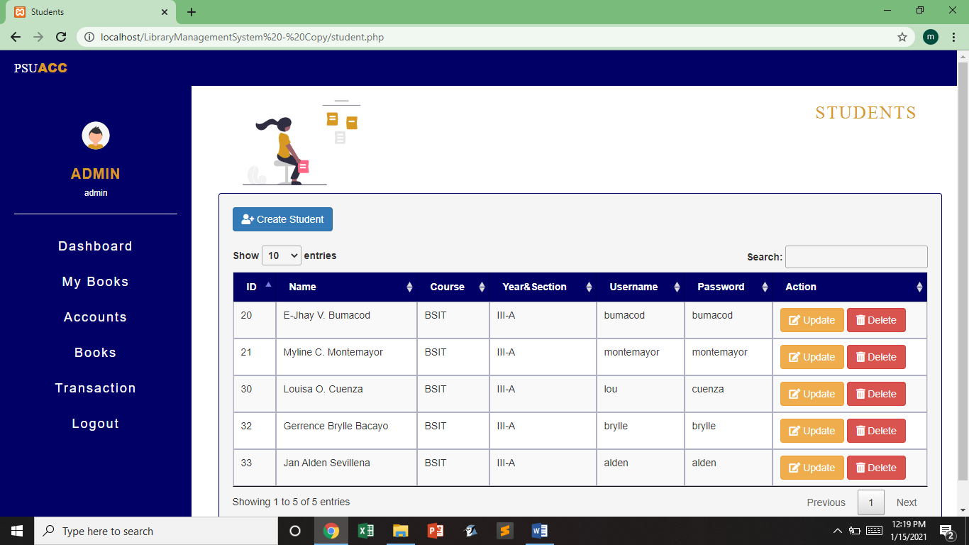

**Students Page:** This part of the system shows all the information of the students registered in the Library System. Admin can create, manipulate and delete the Student account. In order to find an account easier and faster, the admin can use the search bar. Admin can also set the number of student list visible in this page.

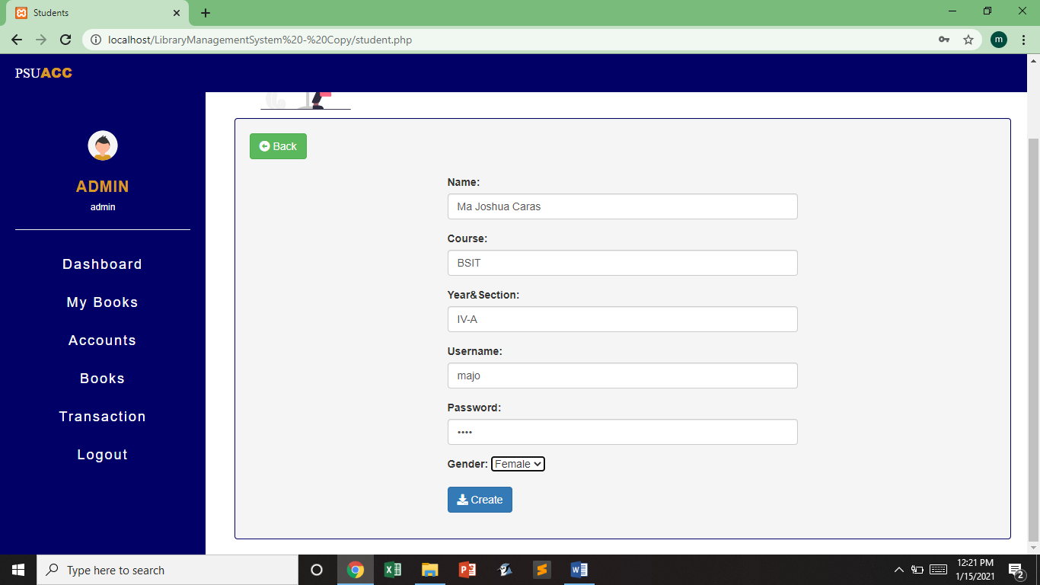

**Create Student:**  Once the admin click the create student button, a form will show up where you can enter the information needed for creating a student account. If the Admin just accidentally click the create student button, no need to worry because there is a back button that will show up along with the form.

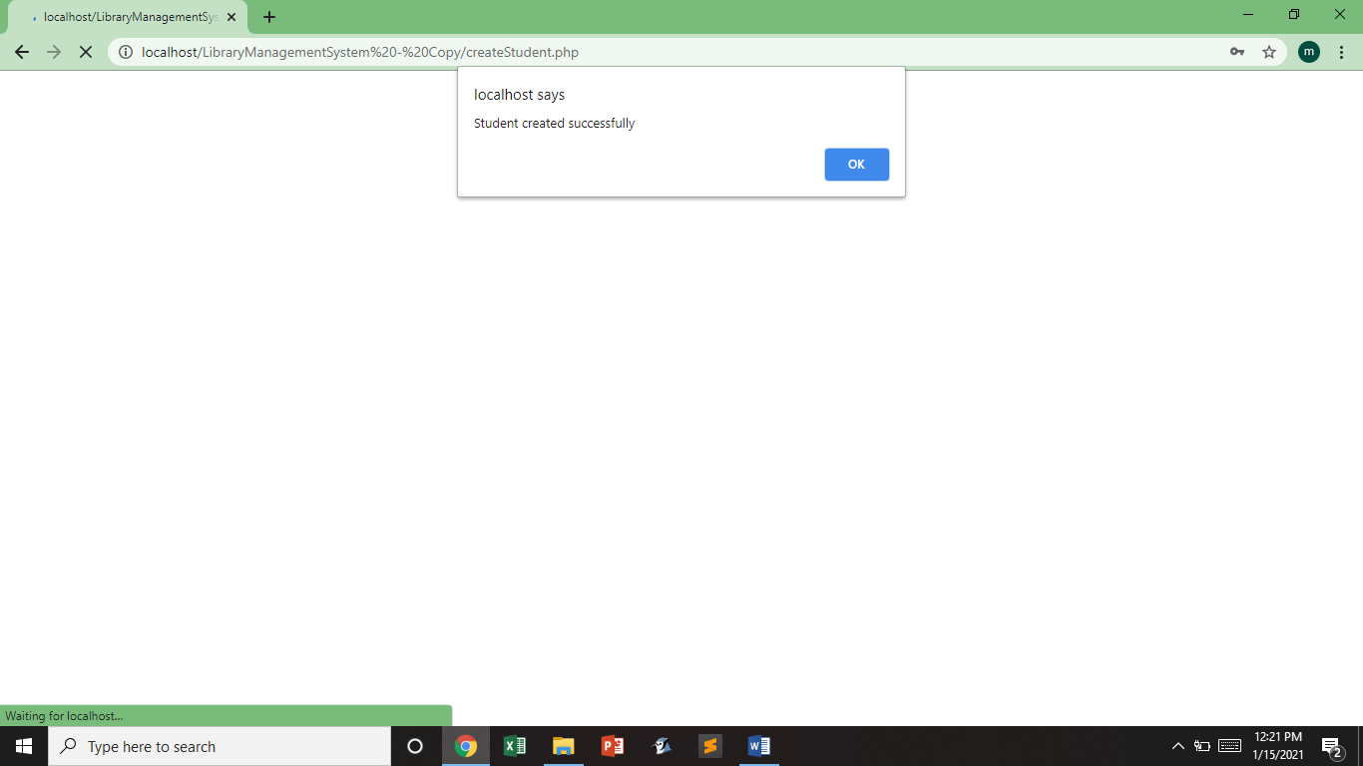

Once the Admin finish filling up the form and click the create button, an alert box will prompt saying that “Student is created successfully”. Just click the ok button and admin will go back to the Students Page.

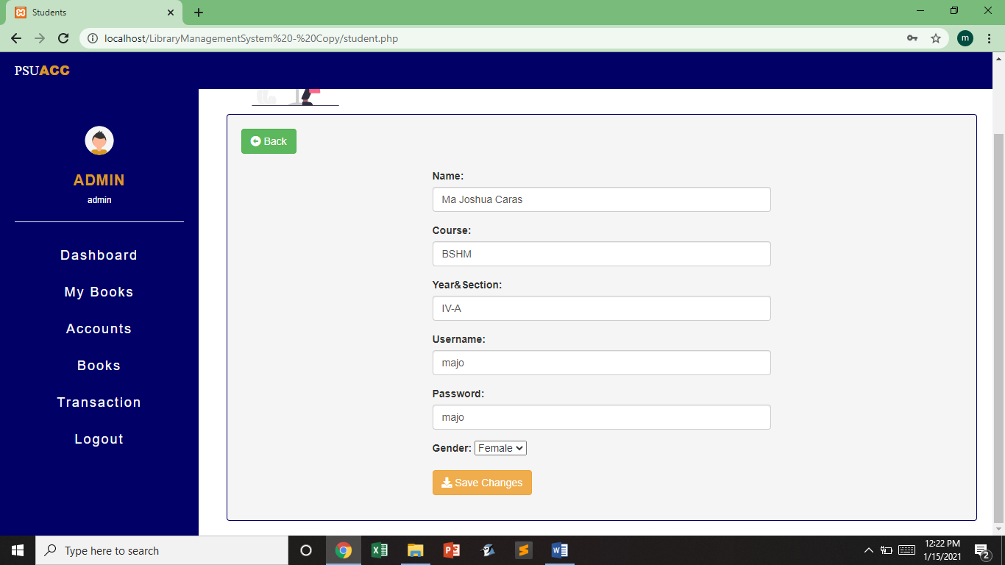

Every students displayed in the Students Page has an update and delete button. Once the update button is clicked, a form containing the present information about the student will appear, then in that moment, admin can update any information of the student account.

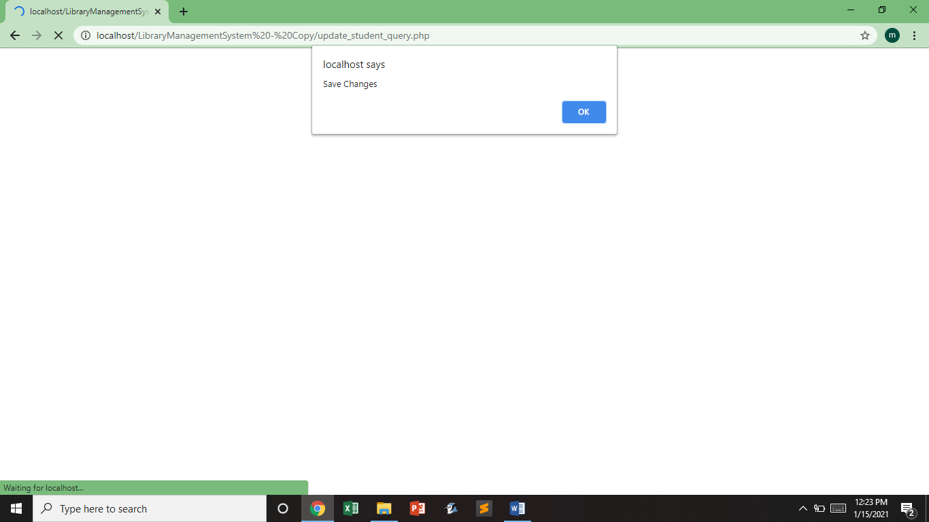

This will prompt up after clicking the save changes button in the Update Form.

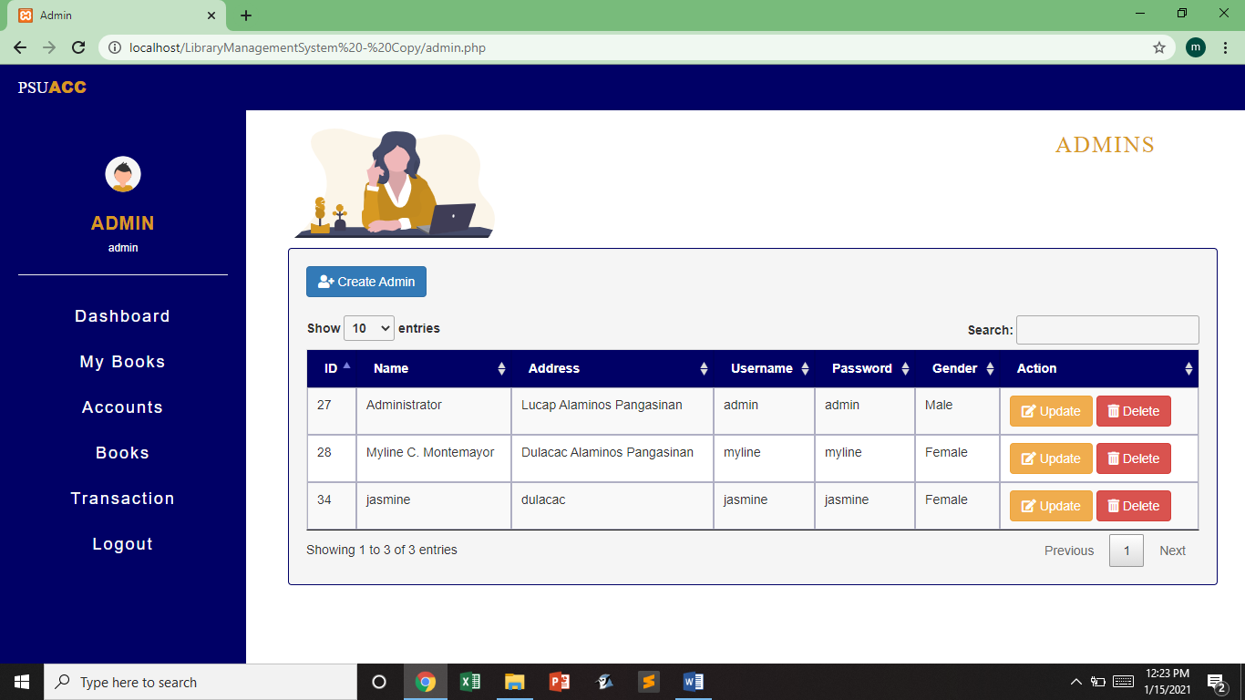

\]\\

**Admin Page:** This part of the system shows all the information of the admins registered in the Library System. Admin can create, manipulate and delete the admin accounts. In order to find an account easier and faster, the admin can use the search bar. Admin can also set the number of admin list visible in this page.

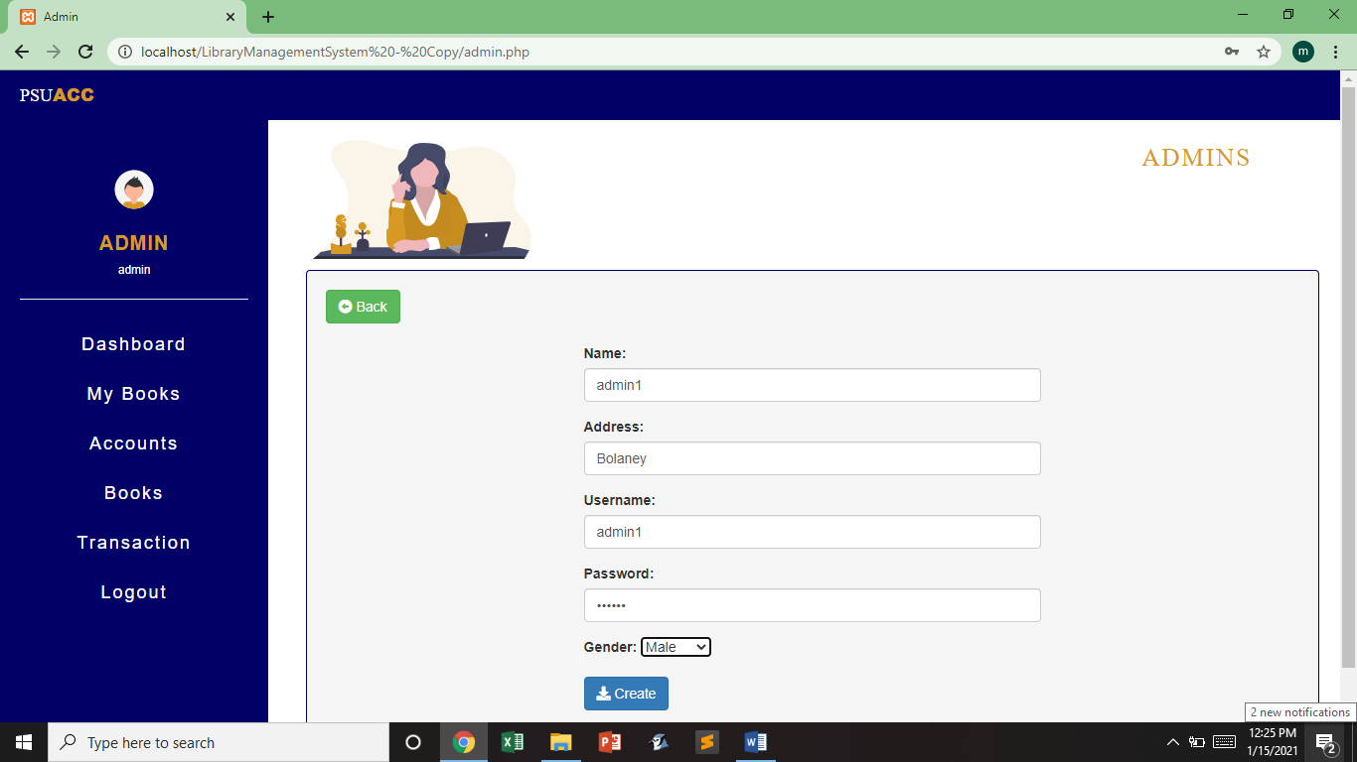

**Create Admin:**  Once the admin click the create admin button, a form will show up where you can enter the information needed for creating an admin account. If the Admin just accidentally click the create admin button, no need to worry because there is a back button that will show up along with the form.

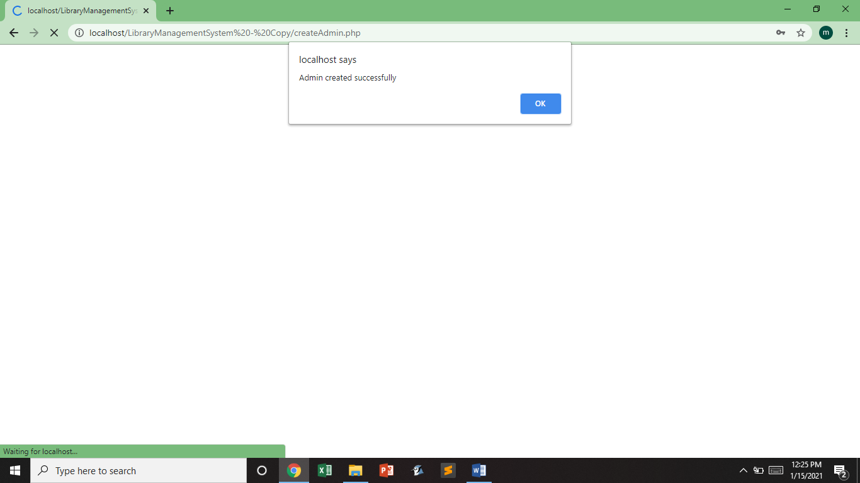

Once the Admin finish filling up the form and click the create button, an alert box will prompt saying that “Admin is created successfully”. Just click the ok button and admin will go back to the Admin Page.

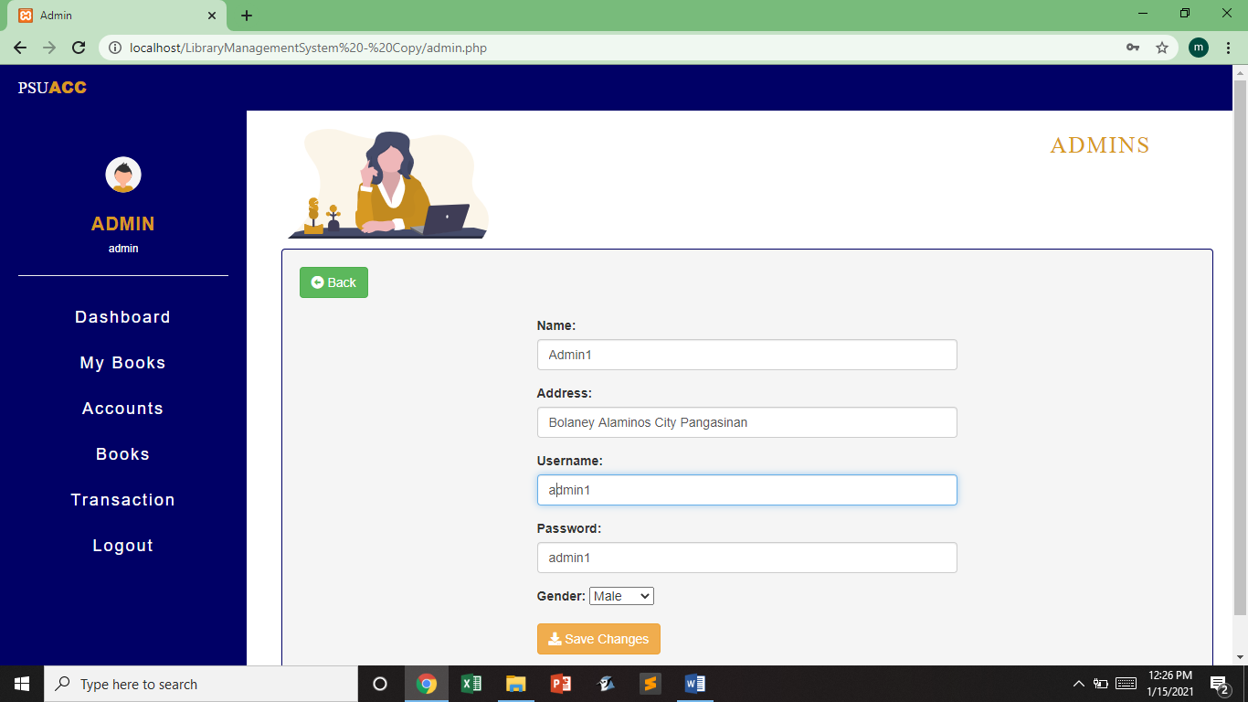

Every Admin displayed in the Admin Page has an update and delete button. Once the update button is clicked, a form containing the present information about the Admin will appear, then in that moment, admin can update any information of the Admin account.

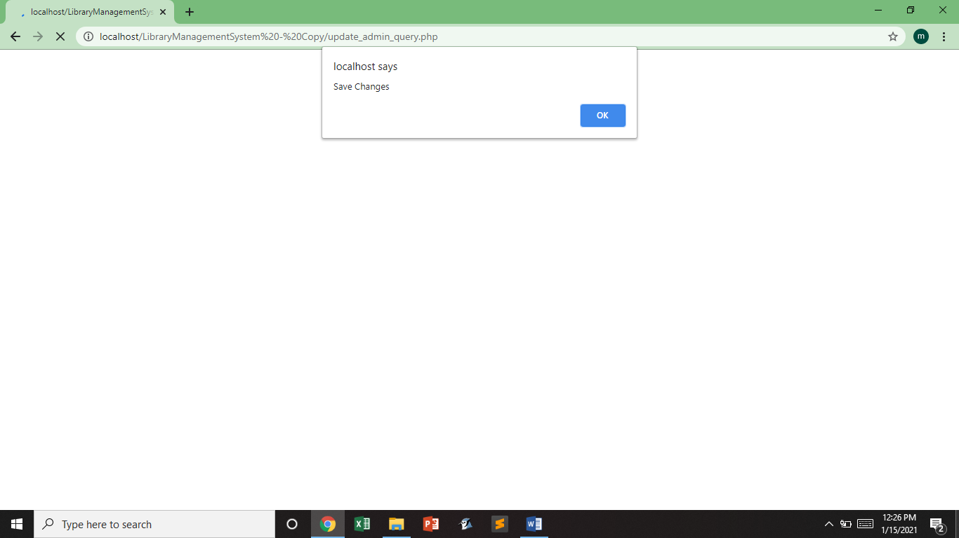

This will prompt up after clicking the save changes button in the Update Form.

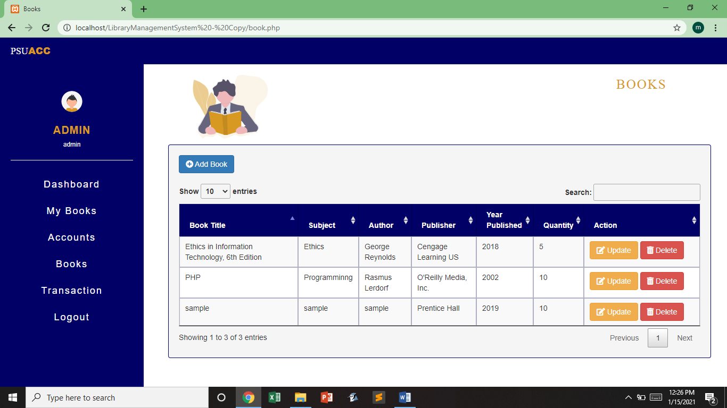

**Book Page:** This part of the system shows all the information of all the books in the Library System. Admin can add, update and delete the book. In order to find a book easier and faster, the admin can use the search bar. Admin can also set the number of book list visible in this page.

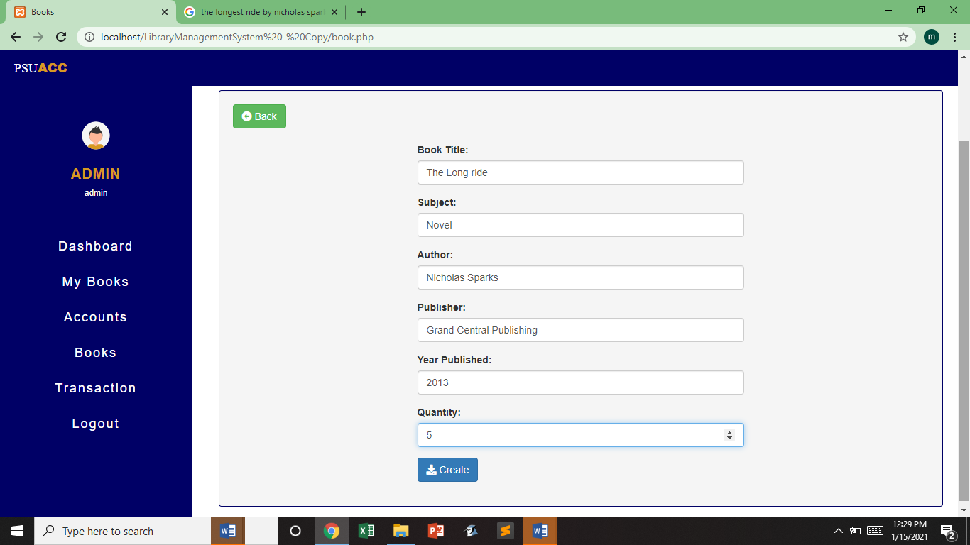

**Add Book:**  Once the admin click the add book button, a form will show up where you can enter the information needed for adding a book in the system. If the Admin just accidentally click the add book button, no need to worry because there is a back button that will show up along with the form.

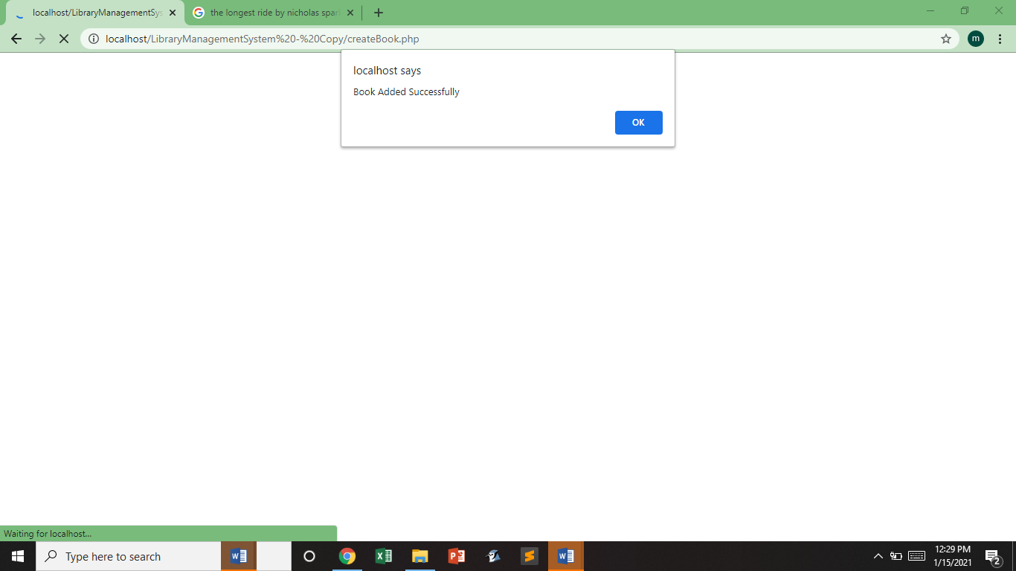

Once the Admin finish filling up the book form and click the create button, an alert box will prompt saying that “Book added successfully”. Just click the ok button and admin will go back to the Book Page.

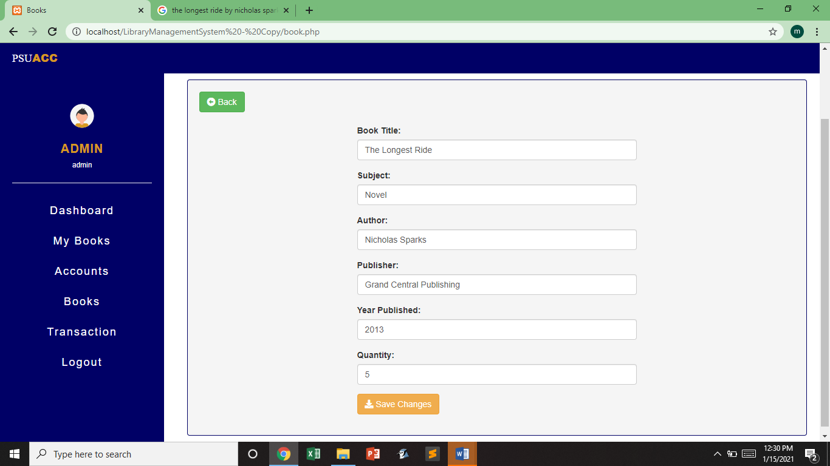

Every book displayed in the Book Page has an update and delete button. Once the update button is clicked, a form containing the present information about the book will appear, then in that moment, admin can update any information of the book.

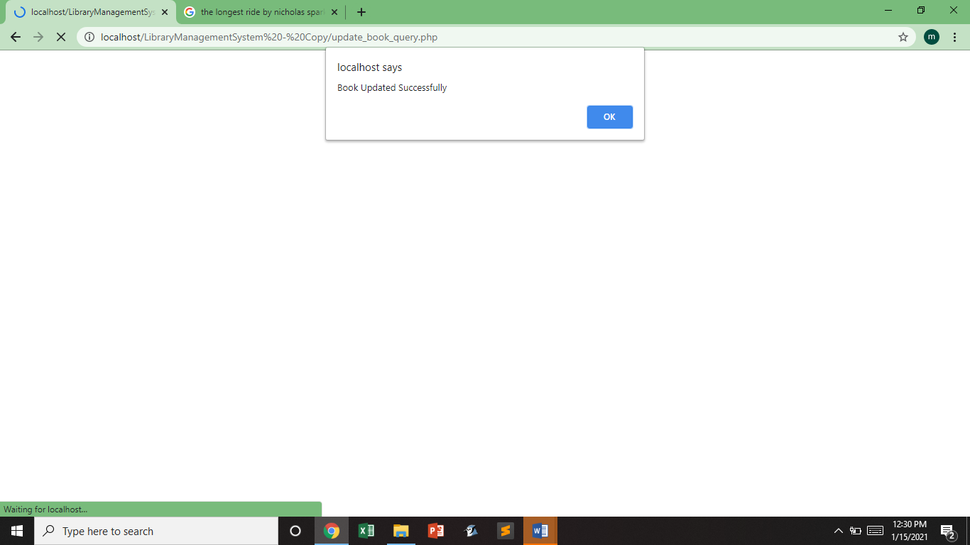

This will prompt up after clicking the save changes button in the Update Form.

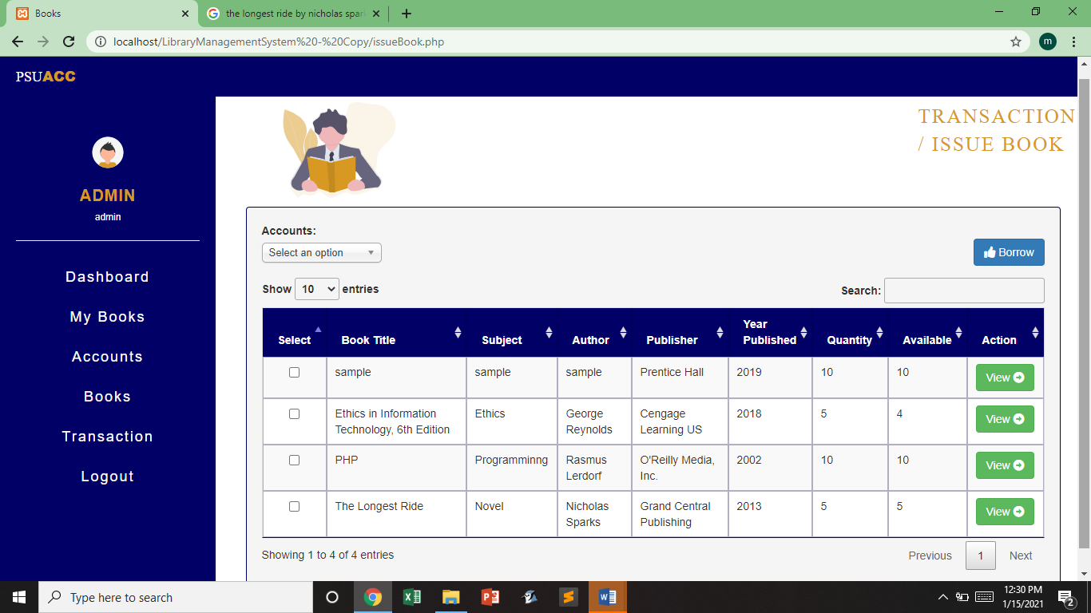

**Issue Book Page:** In this page admin can see all the book information with its quantity and how many is available. The main function of this page is to issue books to any accounts.

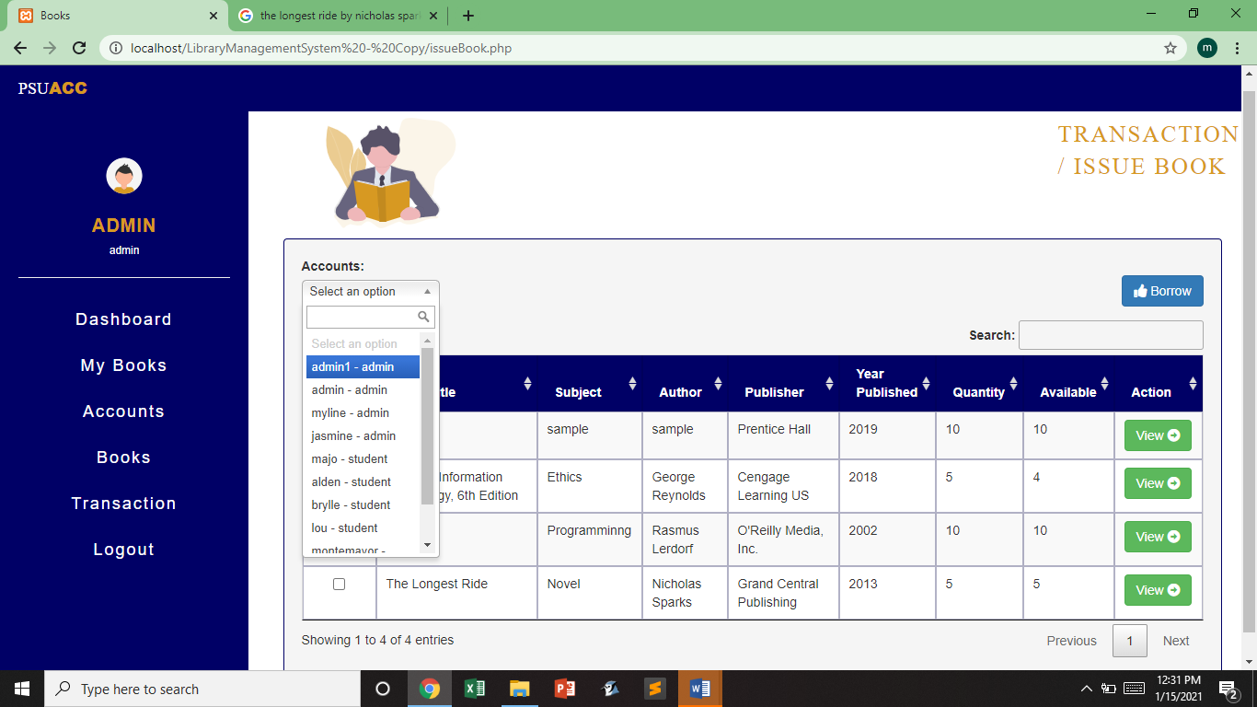

This section of the page contains all the accounts registered in the system, where the admin can choose who he wants to receive a book.

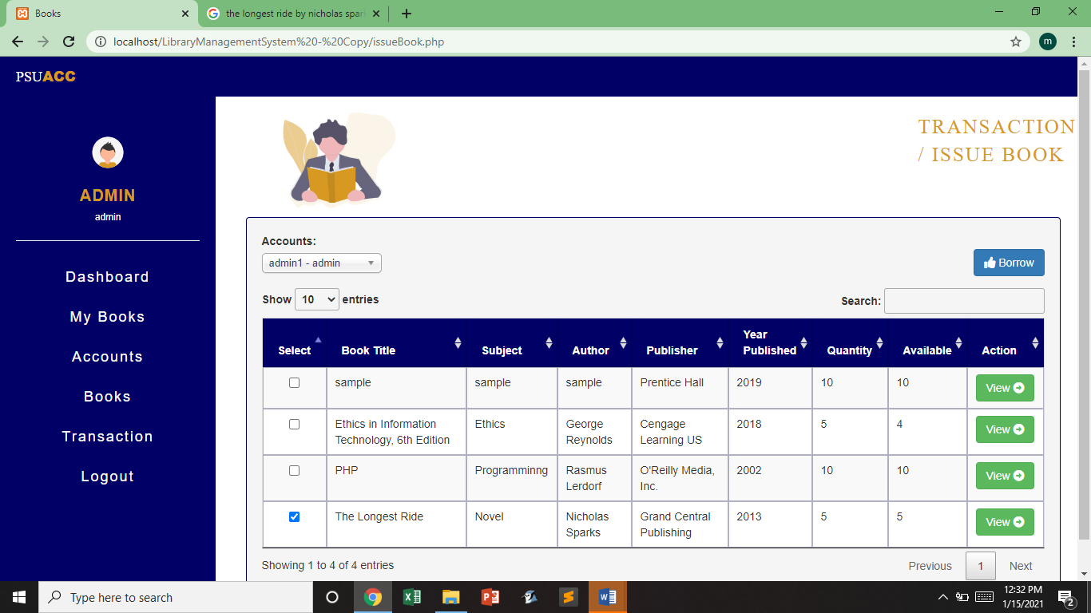

The first column of each row of a book contains a select box. These select box with check indicates that this book is chosen to be issued on the account that has been selected previously.

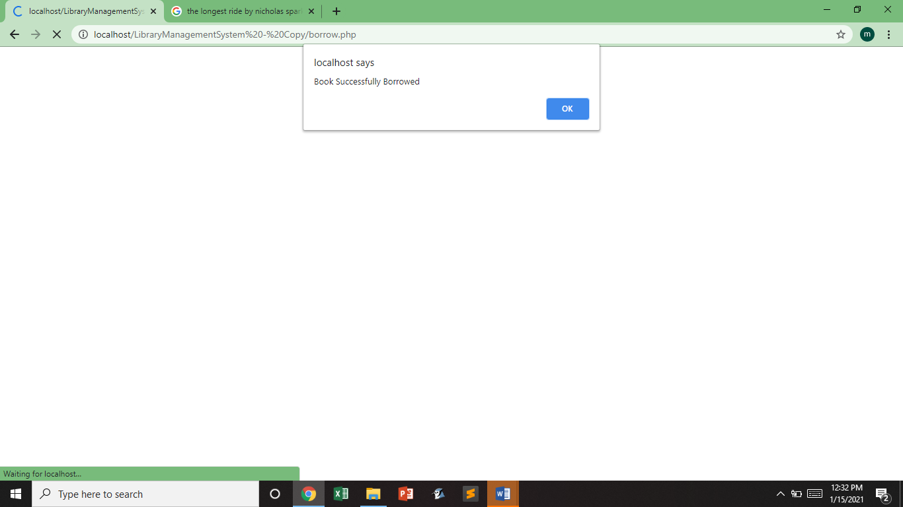

Once the Admin click the borrow button, an alert box will prompt saying that “Book successfully borrowed”. Just click the ok button and admin will go back to the issue Book Page

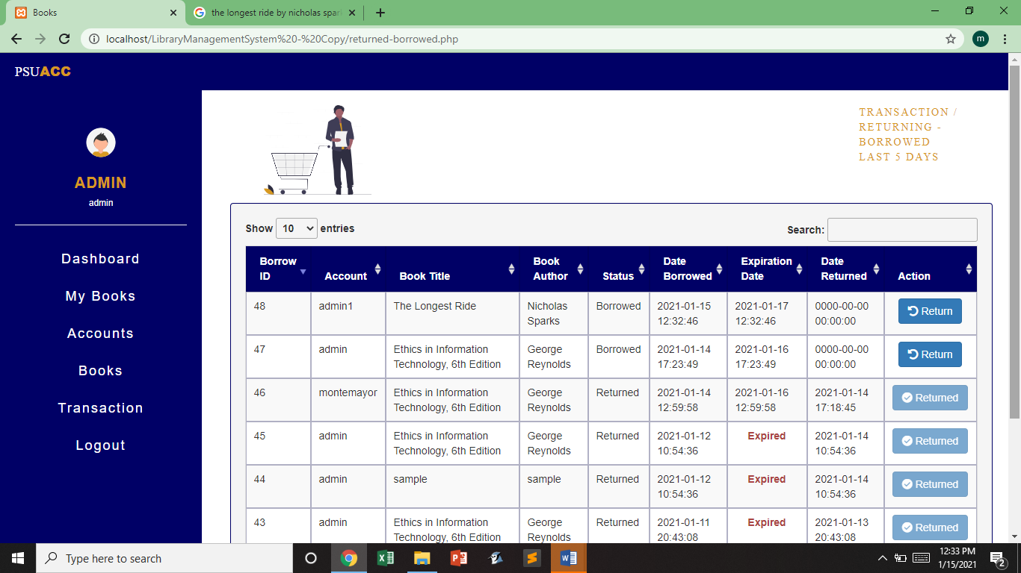

**Returned-Borrowed Page:** This page contains all of the book that has been borrowed and returned. We limit the display time of all the books here in just 5 days, so that the book borrowed will disappear after 5 days since it was borrowed.

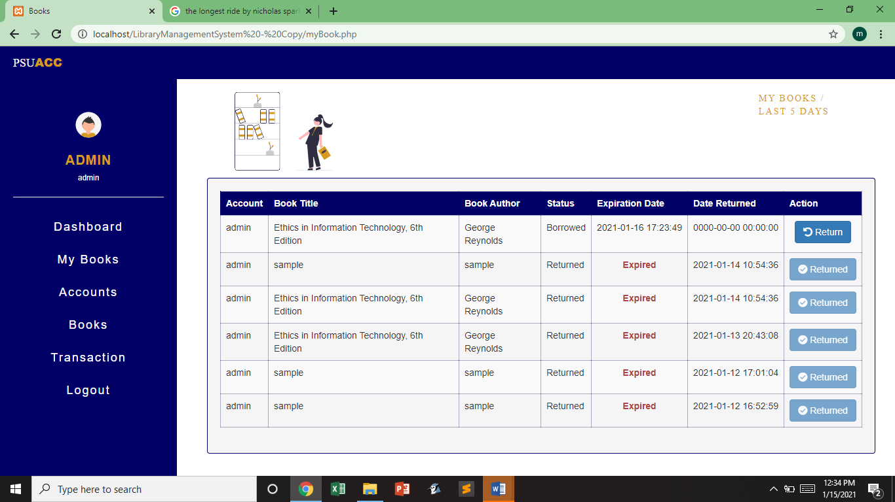

**My Book Page:** In this page, it shows all the books borrowed and previously returned books of the user. There’s a return button

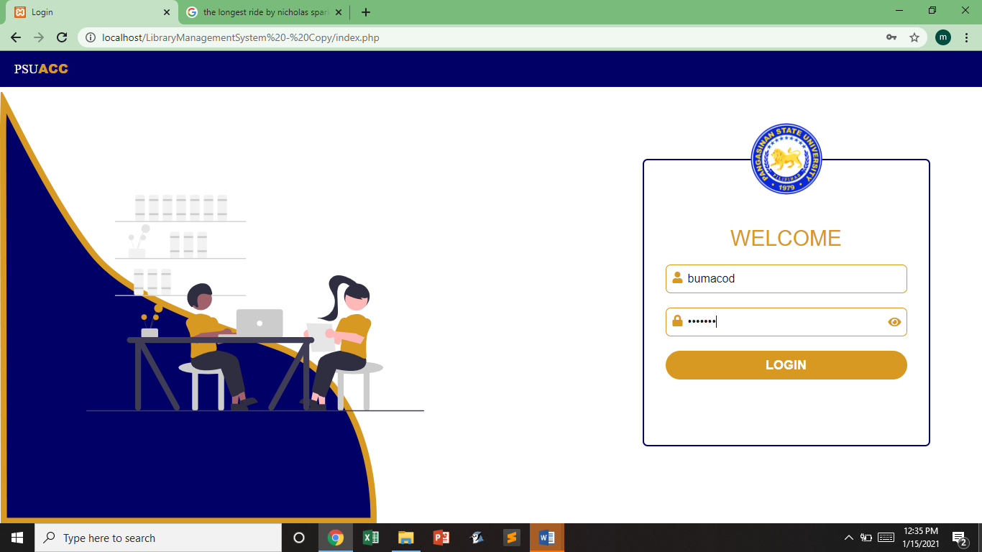

**Login Page:** Admin and Student can log in their account in this page but they have different destination when they logged in.

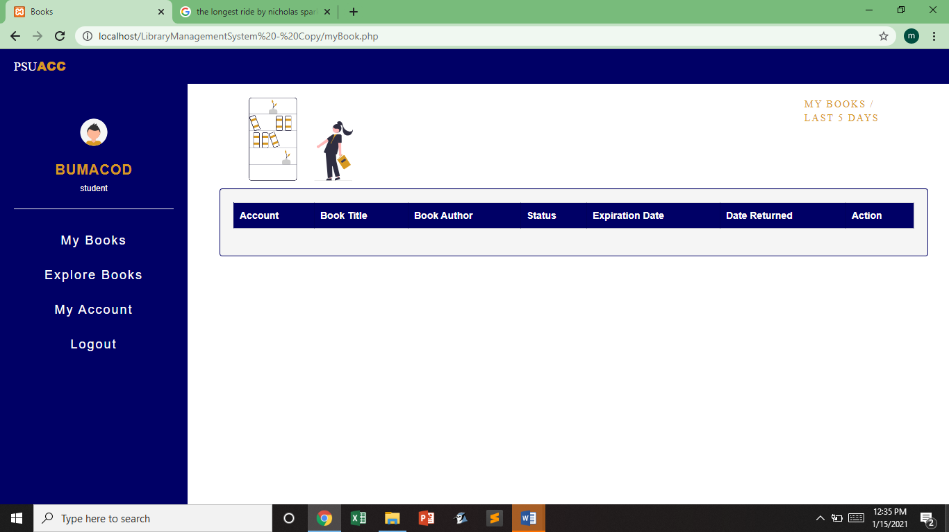

**My book Page:** This is the home page of the students, after logging in, students will direct here.

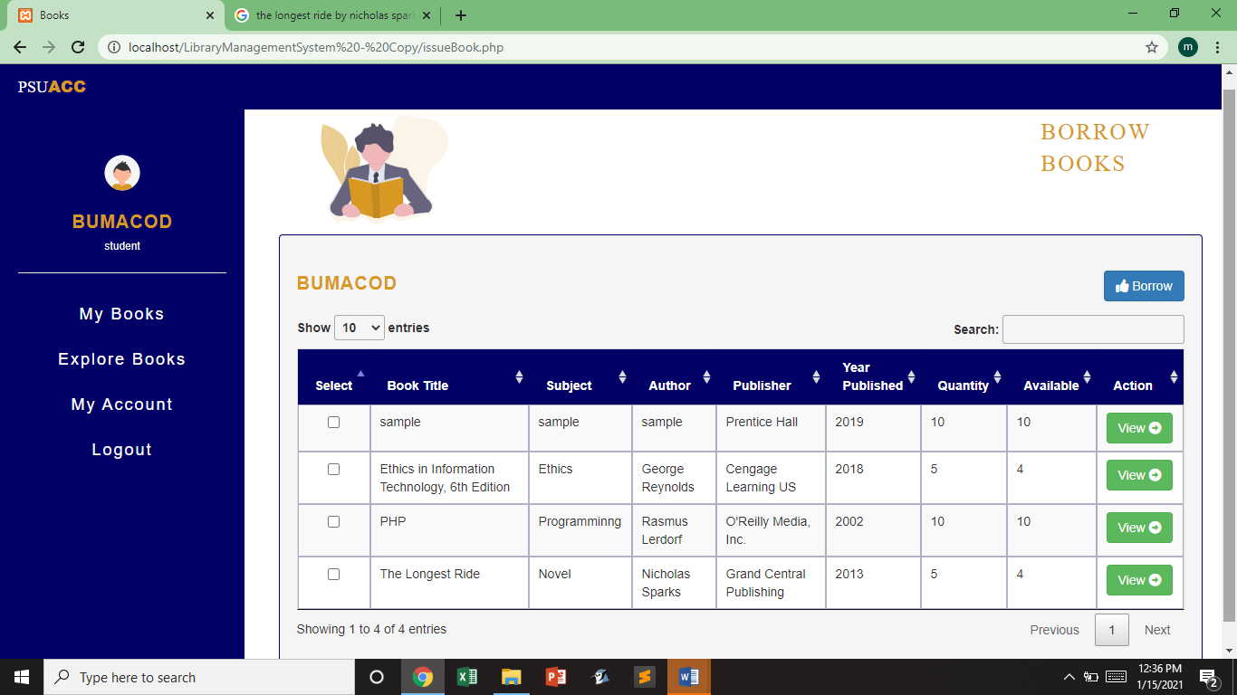

**Explore Book Page:** In this page student can see all the book information with its quantity and how many is available. The main function of this page is to issue books to any accounts. The first column of each row of a book contains a select box. These select box with check indicates that this book is chosen to be borrowed by the student.

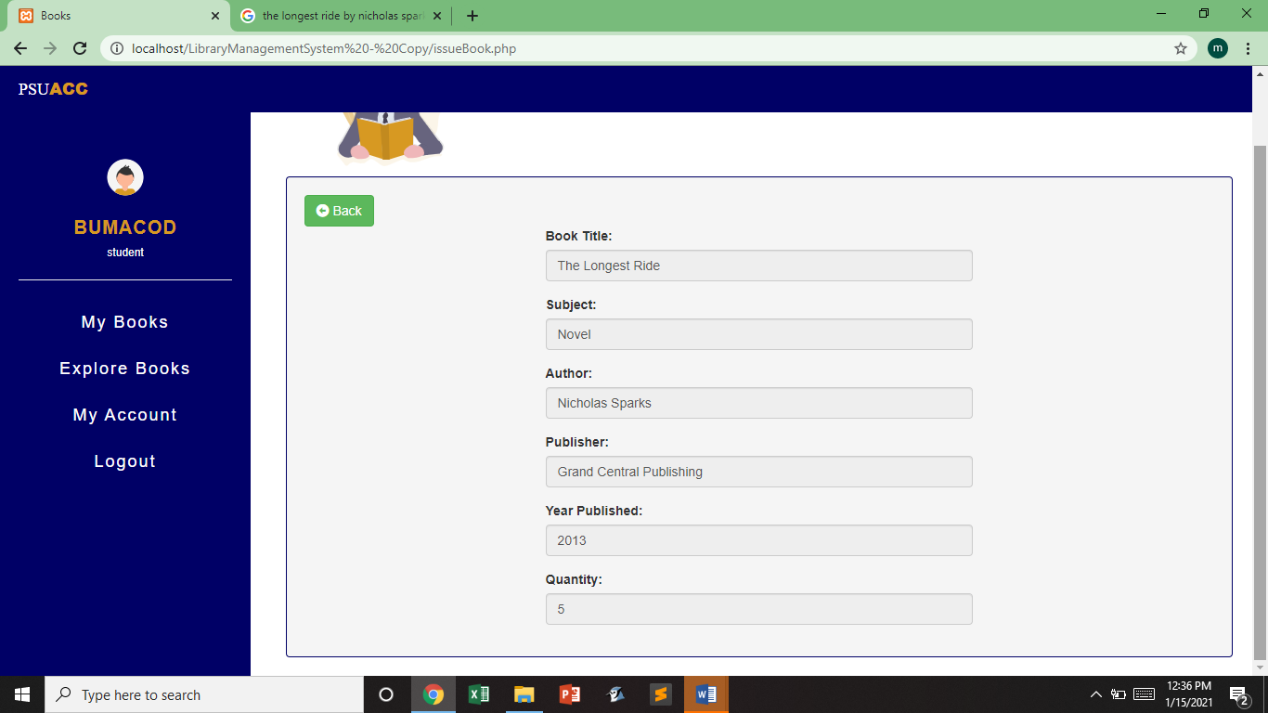

Every book displayed in the Explore Book Page has a view button. Once the view button is clicked, a form containing information about the book will appear.

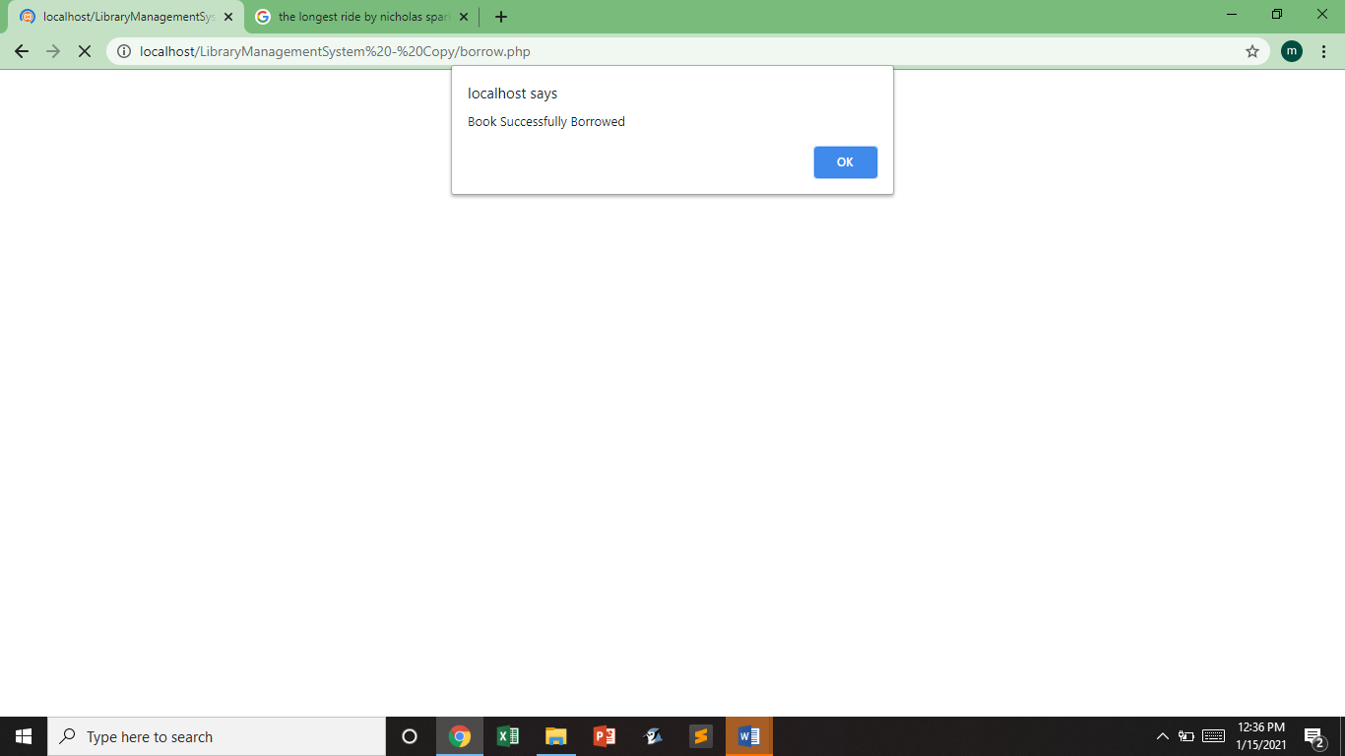

Once the Student click the borrow button, an alert box will prompt saying that “Book successfully borrowed”. Just click the ok button and admin will go back to the Explore Book Page.

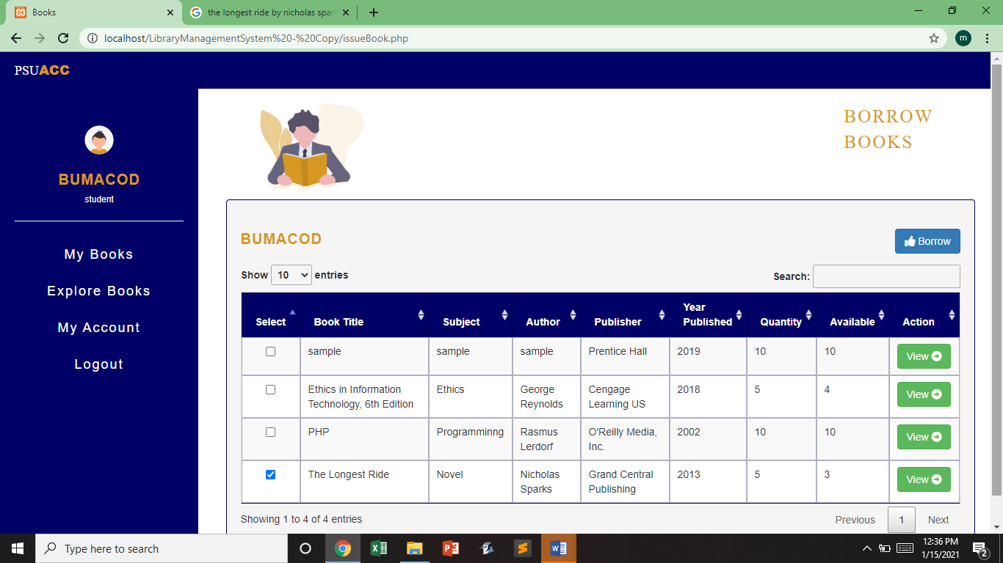

The same Student tries to borrow the same book again.

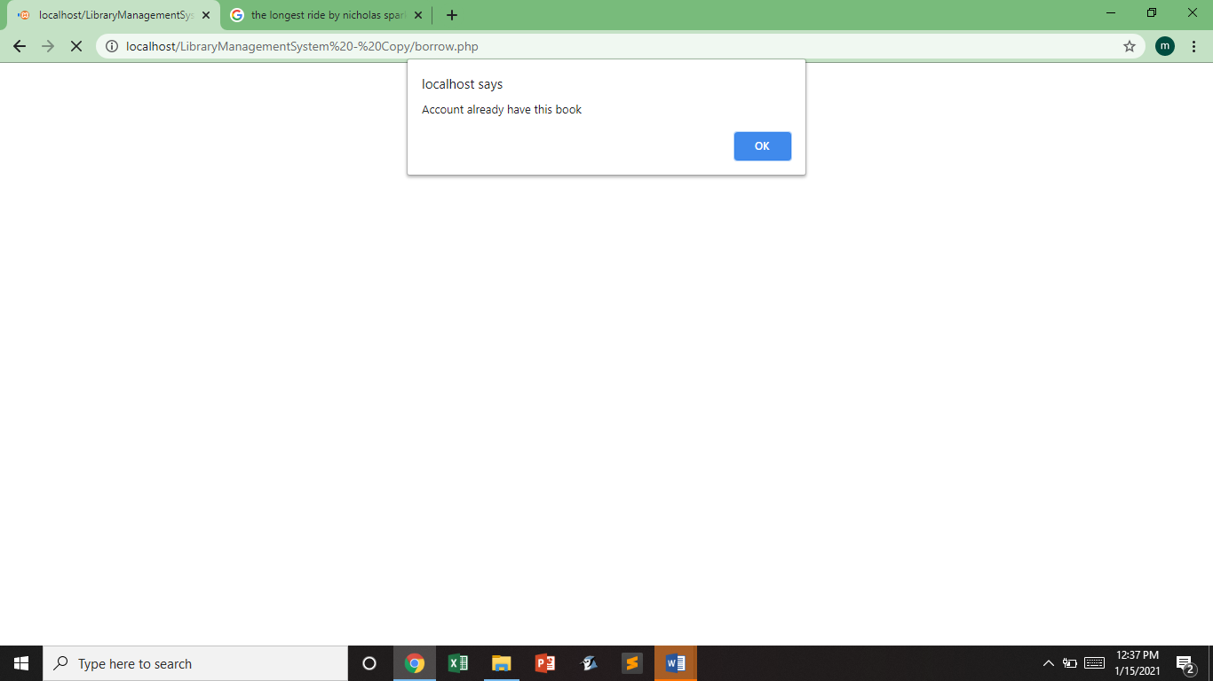

The system will not allow that. It will prompt an alert box saying “Account Already have this book”. Any user can’t borrow 2 the same book at the same time.

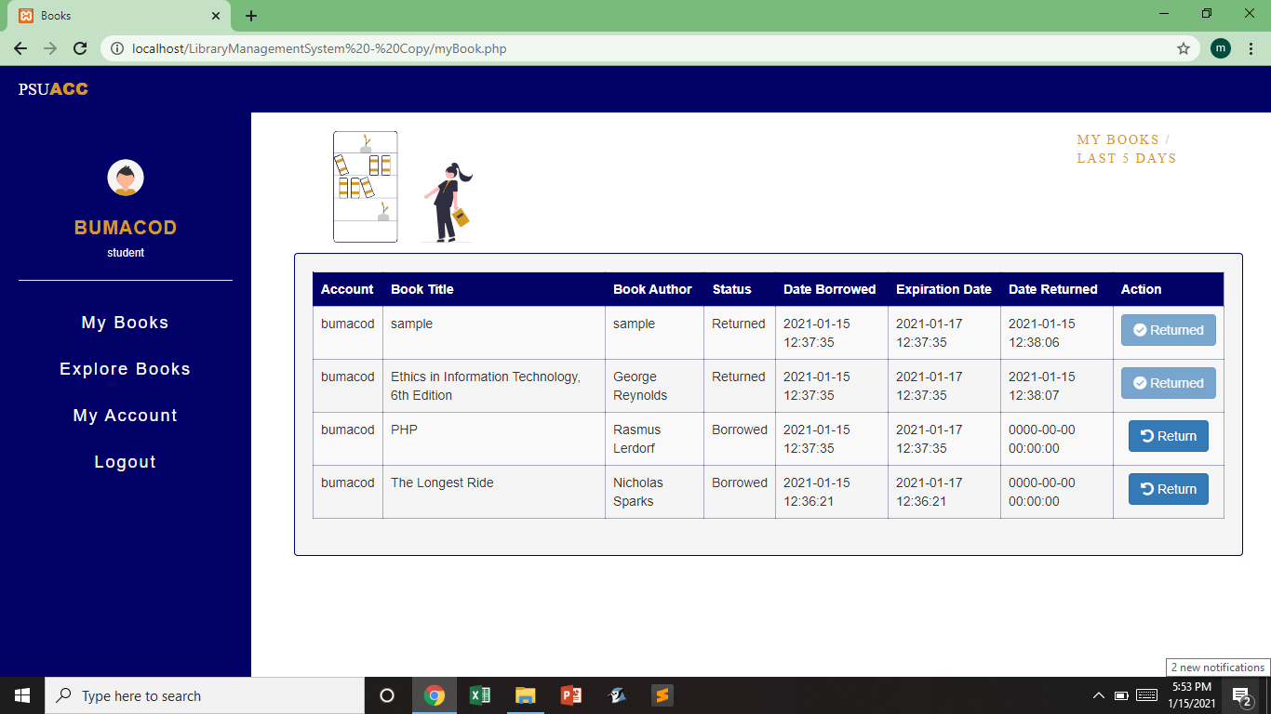

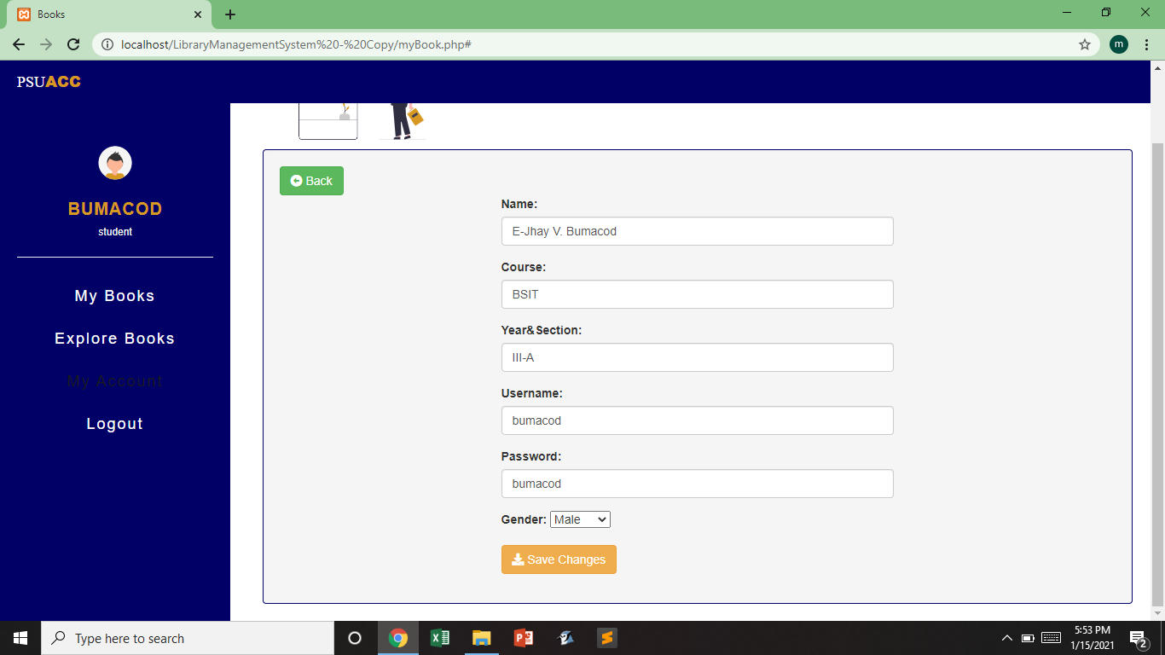**My Book Page:** In this page, it shows all the books borrowed and previously returned books of the user. There’s a return button for every book that has been borrowed.

**My account:** In this section of the page shows the information of the student logged in. Student can also change the information above.